附录5 Appendix 5

世界互联网大会乌镇峰会期间无线电发射
设备限制使用清单及参考图示
List and Reference Diagram of Radio Transmitting Equipment of Restricted Utilization during WIC Wuzhen Summit

- 世界互联网大会乌镇峰会筹备和举办期间限制使用的无线电设备清单
- List of Radio Transmitting Equipment of Restricted Utilization during the preparation and convention of WIC Wuzhen Summit

序号  No. | 各类限制使用的无线电设备  List of Radio Transmitting Equipment of Restricted Utilization
1 | 无线麦克风、无线传声器  wireless microphone
2 | 无线电干扰器或阻断器  wireless jammer or blocker
3 | 无线电直放站、直放机  radio repeater
4 | 手持、车载调频对讲机、基地台设备  hand-held, vehicle-mounted FM interphone, base station equipment
5 | 公众对讲机  public intercom
6 | 手持、车载数字集群对讲机  hand-held and vehicle-mounted digital trunking interphone
7 | 无线遥控玩具、无线遥控（车、船、飞机）模型  wireless remote control toy, wireless remote control (car, boat, plane) model
8 | 无线遥控、遥测设备  wireless remote control and telemetry equipment
9 | 无线摄像机  wireless camera
10 | 无线耳机（蓝牙耳机除外）  wireless headphones (except Bluetooth headphones)
11 | 无线翻译设备、无线监听系统  wireless translation equipment, wireless monitoring system
12 | 各类固定、可搬移式、车载移动式微波传输设备  fixed, portable and vehicle-mounted mobile microwave transmission equipment
13 | 各类无线传感器  wireless sensors
14 | 大功率无绳电话  high power cordless telephone
15 | 卫星移动电话、车载卫星新闻采集设备及固定卫星链路  satellite mobile phone, vehicle-mounted satellite news gathering equipment and fixed satellite link
16 | 卫星地球站及卫星天线  satellite station and satellite antenna
17 | 无线音频/视频传输设备  wireless audio/video transmission equipment
18 | 非嵌入式无线网卡（公众移动通信除外）  non-embedded wireless network card (except public mobile communication)
19 | 无线网络路由器、无线网桥  wireless router, wireless bridge
20 | 无线网络结点设备  wireless node equipment
21 | 测速/测距/测风雷达  Speed/Range/Wind Radar
22 | 长距离非接触式读卡器  long distance non-contact card reader
23 | 具有发射和接收功能的无人驾驶航空器  unmanned aerial vehicle with transmitting and receiving functions
24 | 其他依法需要取得行政许可的无线电台站设备  other radio station equipment that need to obtain administrative license according to law

2、世界互联网大会乌镇峰会筹备及举办期间需要粘贴“无线电设备准入”专用标签的无线电设备参考图示
II. Reference diagram of radio equipment that need to be attached with the label of “Radio Equipment Access” during the preparation and convening of WIC Wuzhen Summit

无线麦克风、无线传声器

Wireless microphone
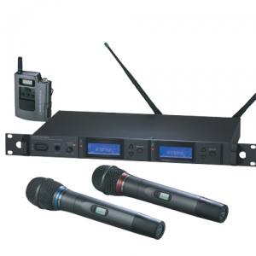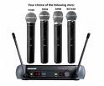

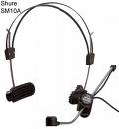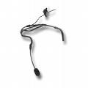

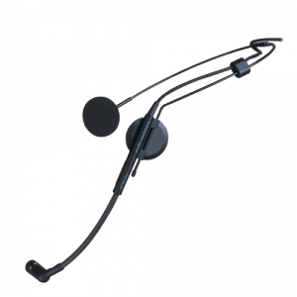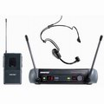
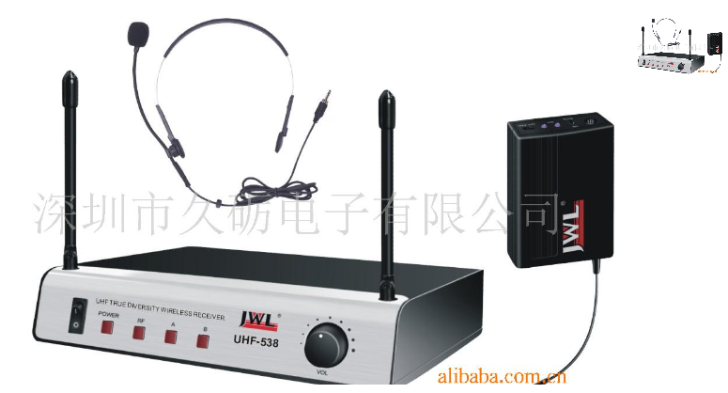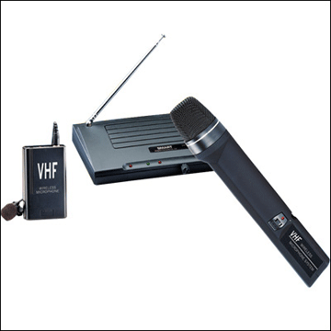

无线电干扰器或者阻断器

Radio jammer or blocker

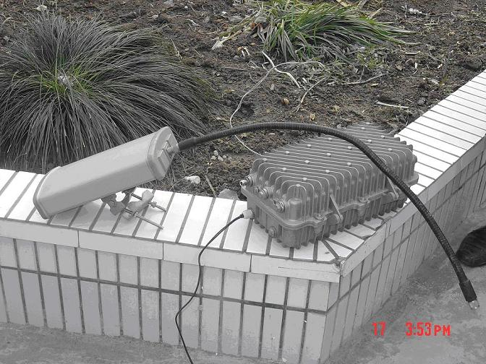

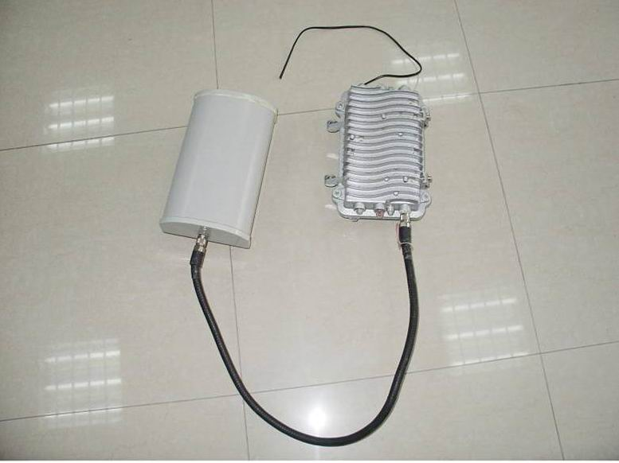

无线电直放站、直放机

Radio repeater
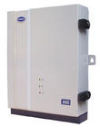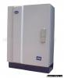

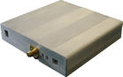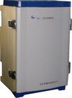

手持、车载调频对讲机、基地台设备

Hand-held, vehicle-mounted FM interphone, base station equipment
手持无线电对讲机(handset talkback)
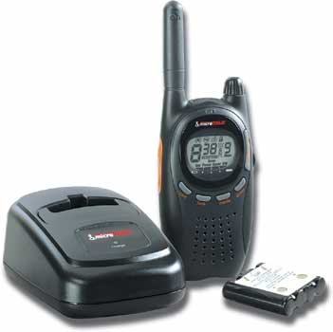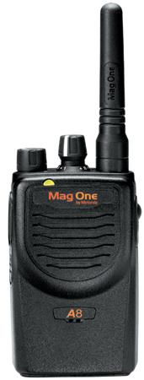

车载无线电对讲机（基地台）(Vehicular station)
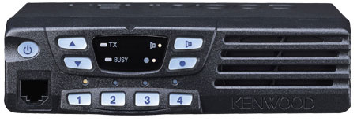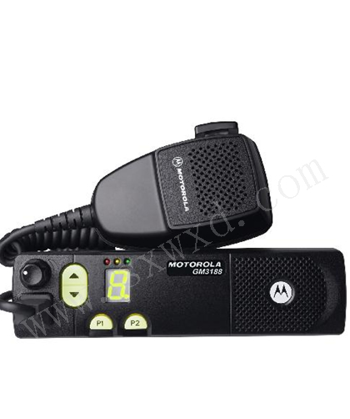

陆地移动无线电基地台(base station)
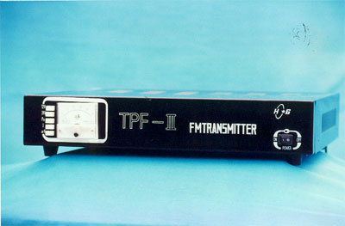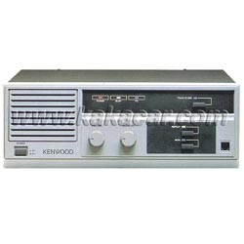

公众对讲机

Public intercom

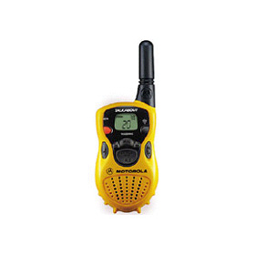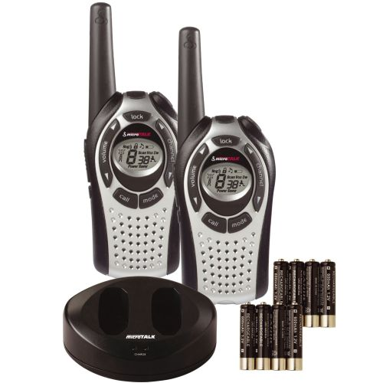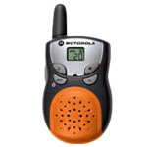

手持、车载数字集群对讲机

Hand-held and vehicle-mounted digital trunking interphone

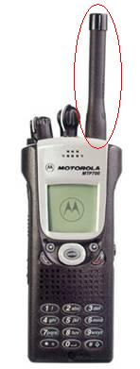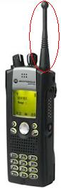

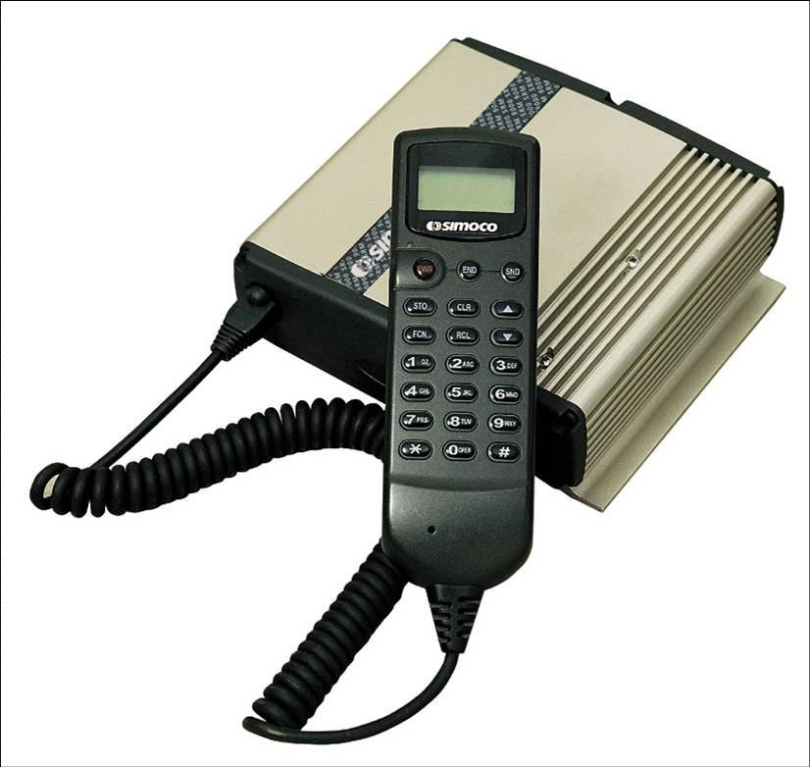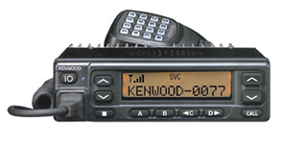

（7）无线遥控玩具、无线遥控（车、船、飞机）模型

Wireless remote control toy, wireless remote control (car, boat, plane) model
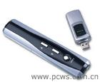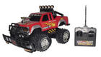

无线遥控、遥测设备

Wireless remote control and telemetry equipment

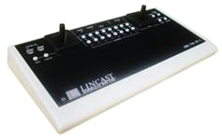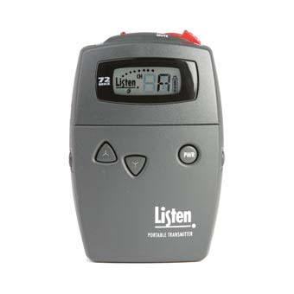

无线摄像机

Wireless camera

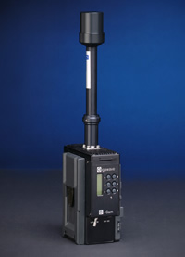

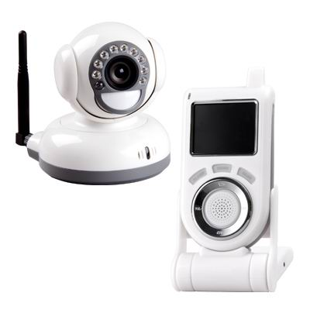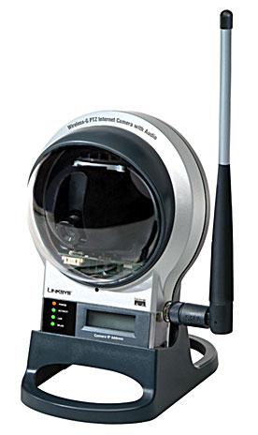

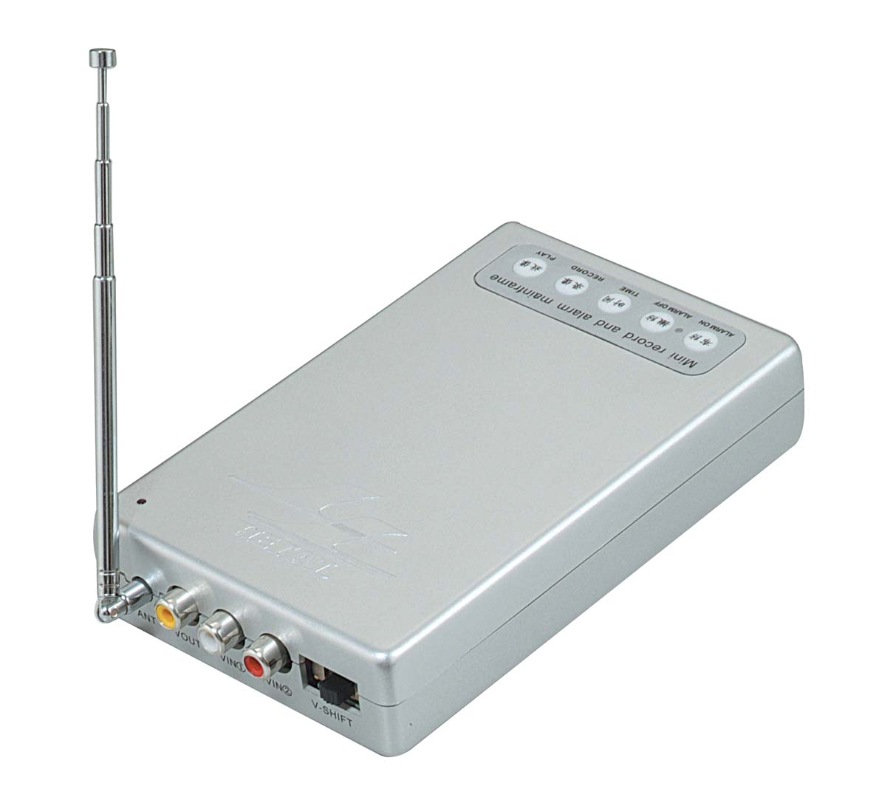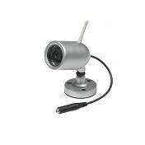

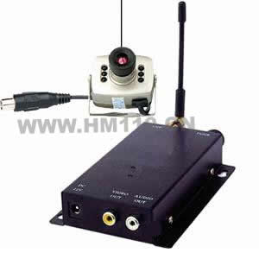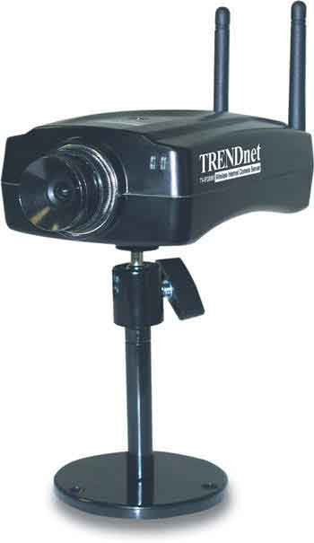

无线耳机（手机耳机除外）

Wireless headphones (except mobile phone headphones)
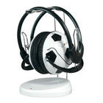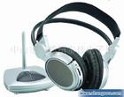

无线翻译、无线监听系统

Wireless translation and wireless monitoring system
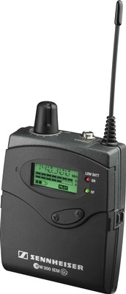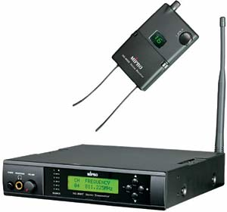

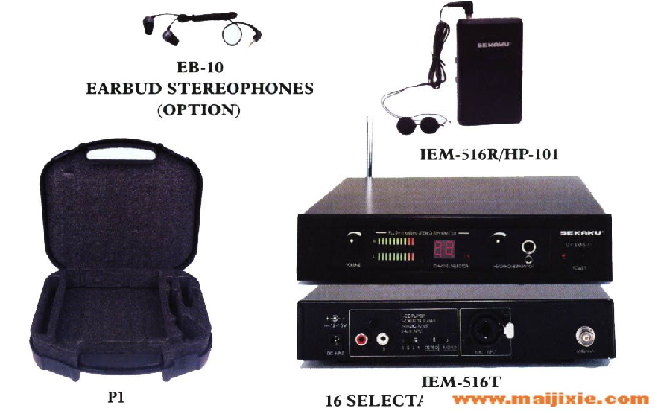
翻译系统(Interpretation system)
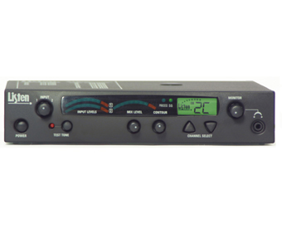

各类固定、可搬移式、车载移动式微波传输设备

Fixed, portable and vehicle-mounted mobile microwave transmission equipment
固定卫星链路(Fixed satellite link)
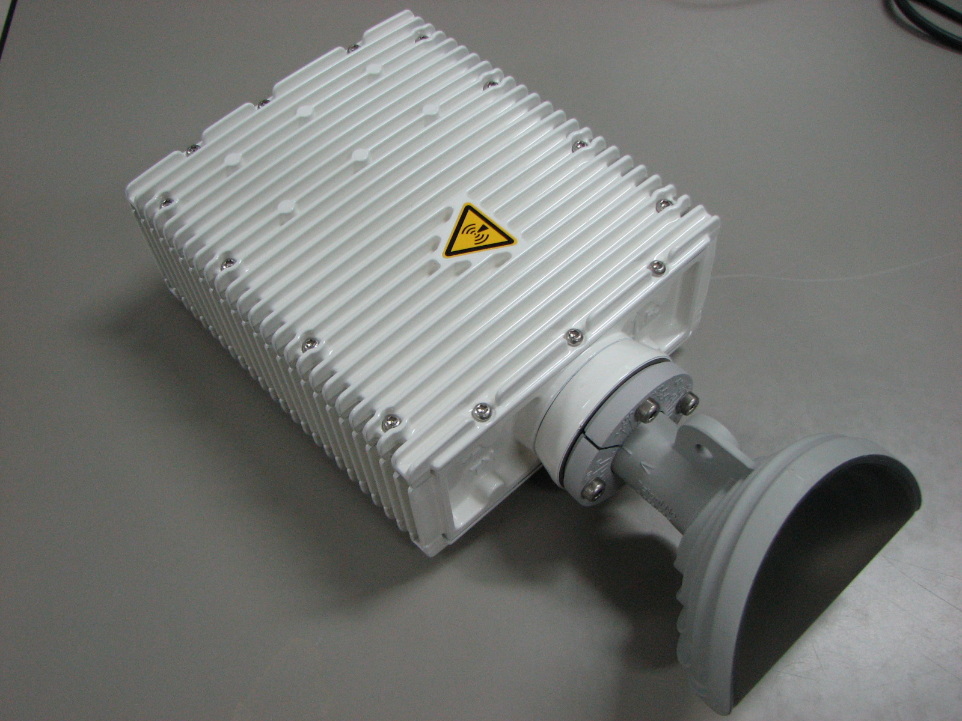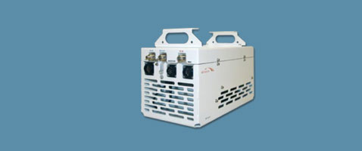

固定微波链路(Fixed microwave link)
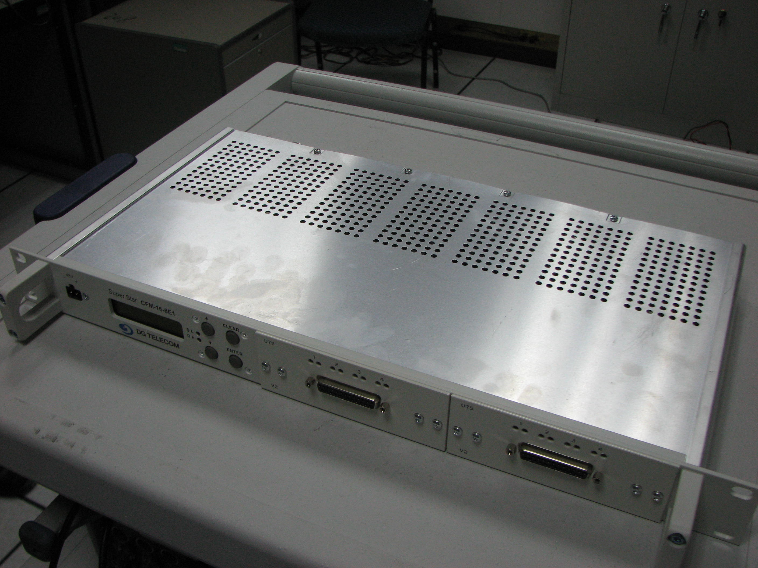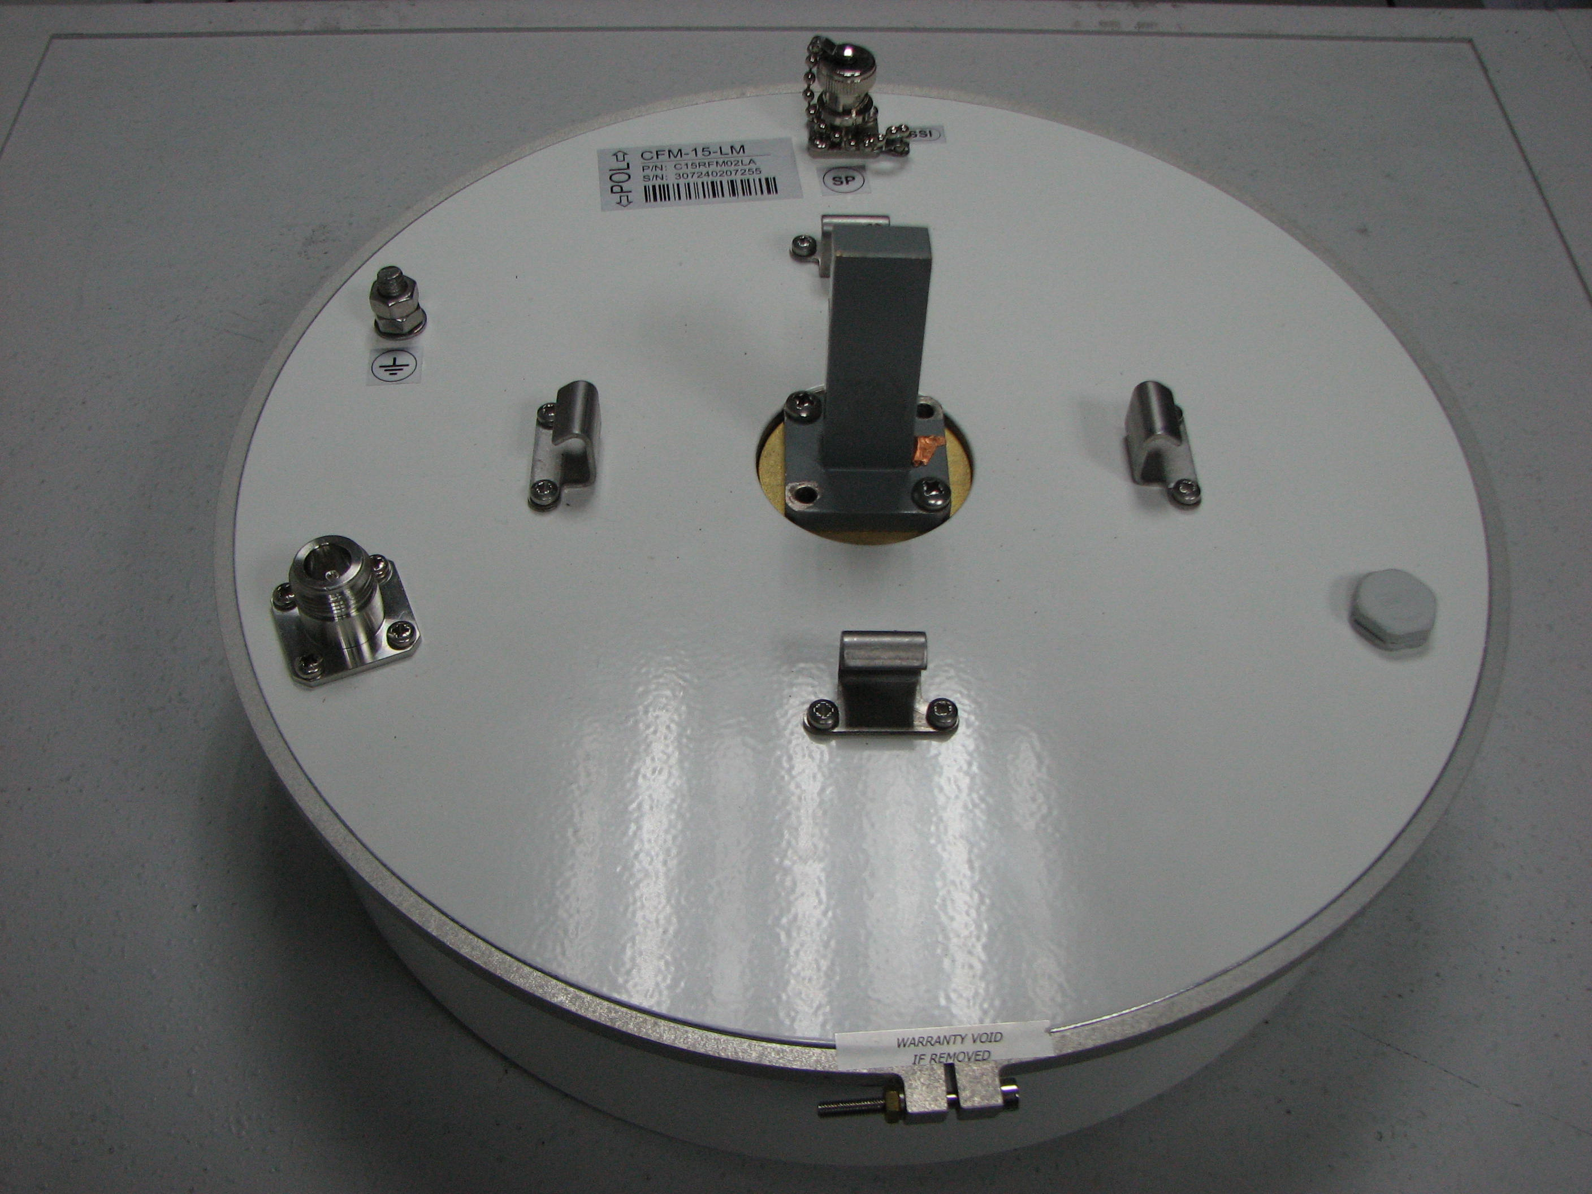
移动微波链路(Mobile microwave link)
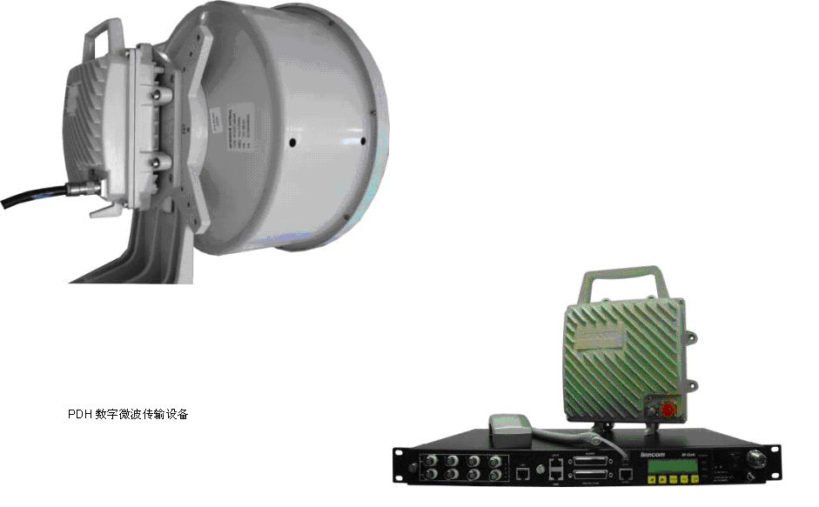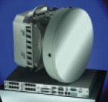

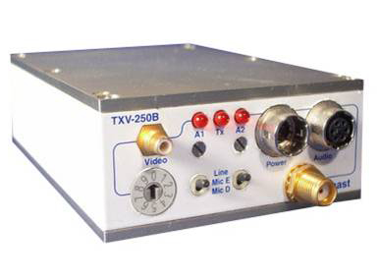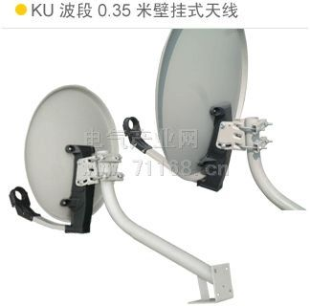

各类无线传感器

Wireless sensor
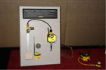

大功率无绳电话

High power cordless telephone
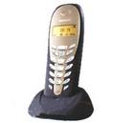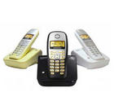
- 卫星移动电话、车载卫星新闻采集设备及固定卫星链路

Satellite mobile phone, vehicle-mounted satellite news gathering equipment and fixed satellite link
卫星移动电话（Satellite mobile phone）
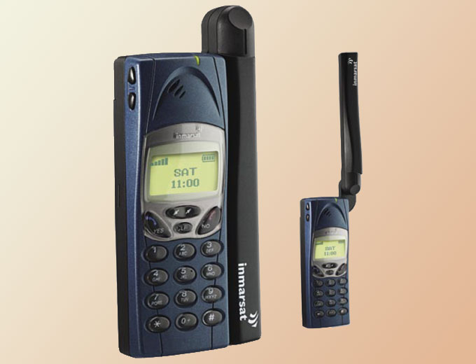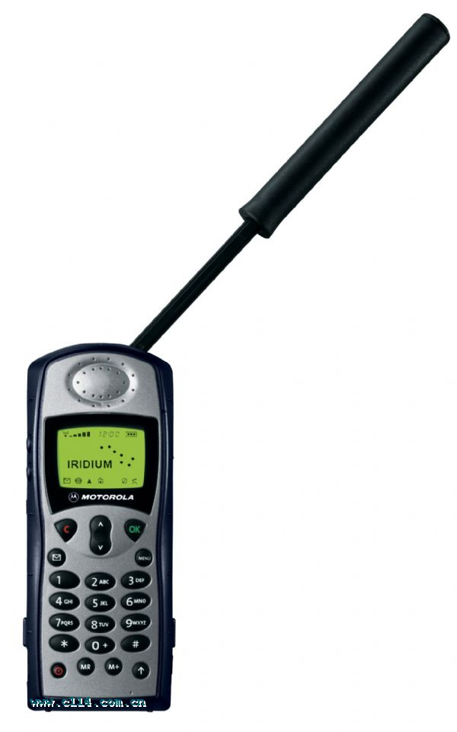
新闻采集设备(Satellite news gathering equipment)
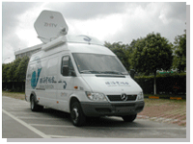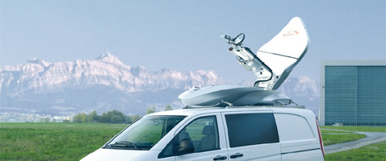

卫星地球站、卫星天线

Satellite station, satellite antenna
固定卫星链路及卫星天线（Fixed satellite link and satellite antenna）
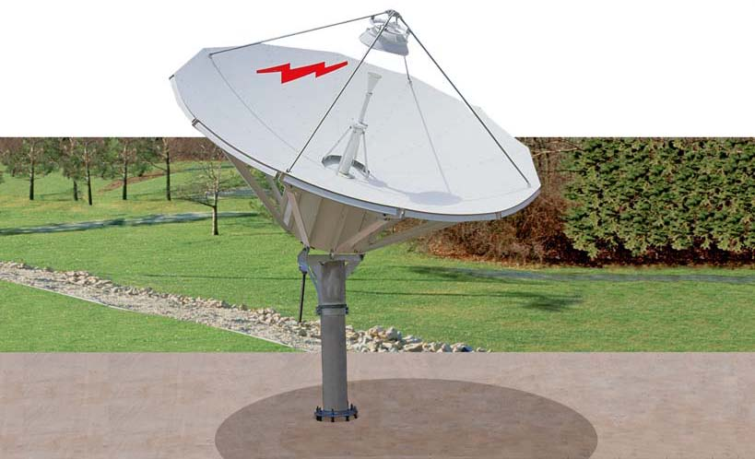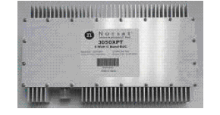

移动卫星地球站 (Mobile Satellite earth station)

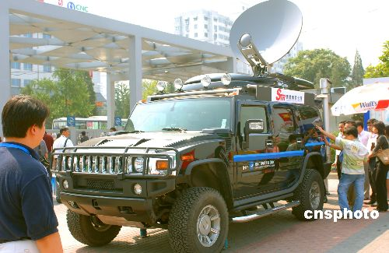

无线音频/视频传输设备

Wireless audio/video transmission equipment
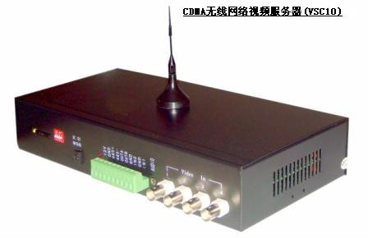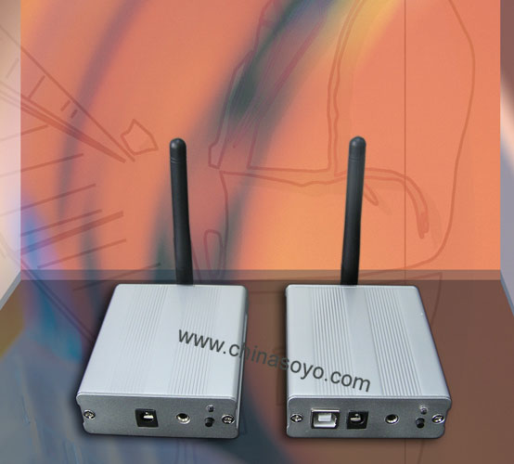

非嵌入式无线网卡(公众移动通信除外)

Non-embedded wireless network card (except for public mobile communication)

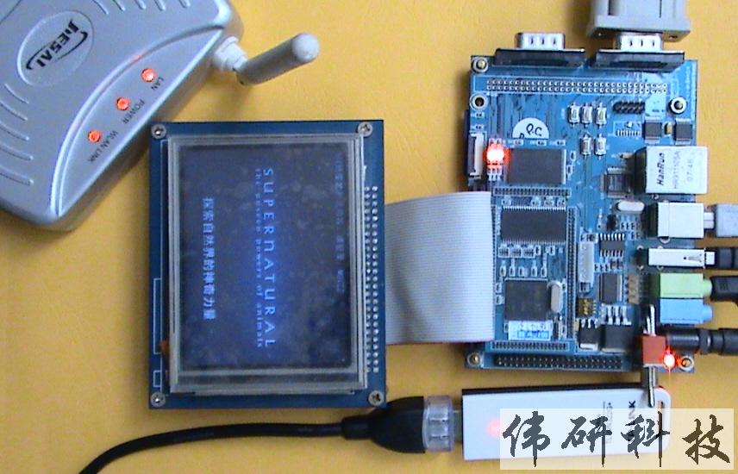

无线网络路由器、无线网桥

Wireless router, wireless bridge

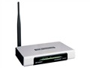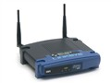

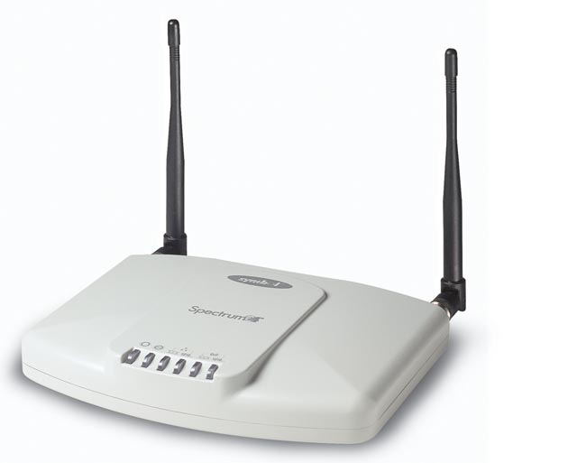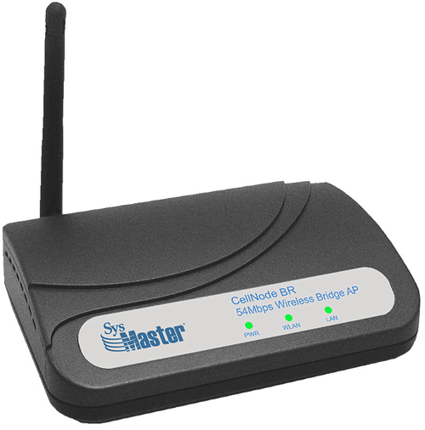

无线网络结点设备

Wireless node equipment
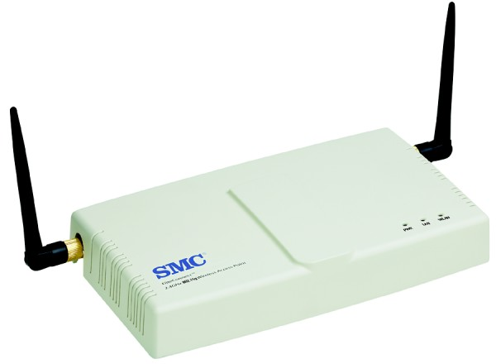

测速/测距/测风雷达

Speed/Range/Wind Radar
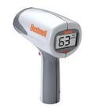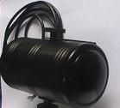

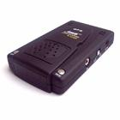

长距离非接触式读卡器

Long distance non-contact card reader
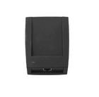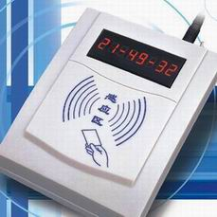
- 具有发射和接收功能的无人驾驶航空器

Unmanned aerial vehicle with transmitting and receiving functions
